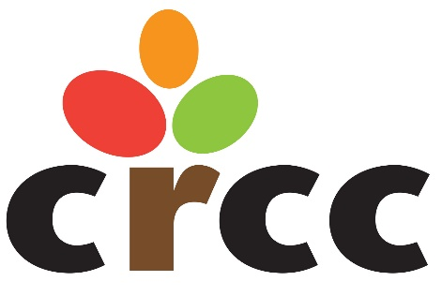

Job Description

Job Title: Communications Coordinator

Responsible To: Development Director

General Duties: Responsible for furthering the CRCC mission and building awareness of CRCC programing through utilization of the various communication channels available. Additional duties may be assigned as required.

Essential Functions:
- Develop and execute overarching communications/marketing plan in alignment with CRCC’s newly adopted strategic plan;
- Partner with Advocacy, Development, Operations and Executive Leadership Team on internal and external communication efforts related to the various audiences (elected officials, donors, CRCC partner organizations, community, families, employees);
- Oversee all aspects of the organization’s marketing and external communications. Apply brand standards; develop and execute marketing campaigns; create and distribute paid, owned and earned content; manage communications budget and actively pursue innovative opportunities to increase brand awareness;
- Develop and delivers content including copywriting, editing, assisting in new business efforts, media relations, and events;
- Assist in development and design of external and internal marketing assets;
- Develop social media strategy and execute campaigns—including reporting and analysis of effectiveness;
- Assist in leveraging various technological resources including: Bloomerang, Constant Contact, Lifeloop, Qgiv, etc.;
- Oversee website content and utilization of calendars and news.

Minimum Qualifications:
- Bachelor’s degree in Communications, Marketing, or related field and/or three years of communications/marketing experience required. Experience with a non-profit organization is preferred;
- Strong social media experience across multiple platforms and resources;
- Strong verbal, writing, and presentation skills;
- Ability to quickly and easily adapt to changing priorities;
- Understanding of available resources and channels of communication;
- Proven ability to be a detail-oriented, creative problem solver that is able to manage multiple projects simultaneously;
- Ability to work in a variety of situations with a variety of personalities;
- Ability to think creatively and willing to bring new ideas and approaches to the team;
- Demonstrates continuous learning to stay on top of evolving trends, medias, and opportunities as it relates to the strategic marketing effort of the organization;
- Familiarity or ability to learn Microsoft Office programs, project management systems, Adobe Creative Suite, HTML, and/or WordPress;
- Able to meet agency’s conditions of employment regarding health status and clearance with the Nebraska Child Abuse/Neglect Central Registry and/or Adult Abuse/Neglect Registry and the Nebraska State Patrol.

